GROOMING
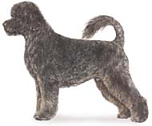
Portuguese Water Dogs have an abundant coat with strong hair, and no undercoat. PWDs technically come in two coats, the wavy and the curly, but you also find some described as "loose curly" which fall somewhere in between. Though PWDs do not have an undercoat, there is still hair shed and tangling to be managed. Owners of Portuguese Water Dogs will have to make some styling decisions as there are several ways to groom the full-coated dog. Show grooms are limited in what is acceptable for the conformation ring. The two accepted cuts for the Portuguese Water Dog are the retriever trim and the lion trim.
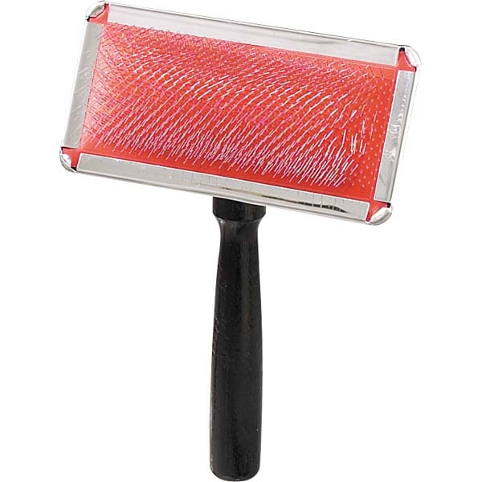
Washing

Get a half quart or litter sized bottle, add about 1/2 inch to 1 inch of a concentrated shampoo to the bottle, and for dirty dogs add another 1/4 inch of Dawn dishwashing some the mix with warm water. Wet the dog with lukewarm water. Dogs prefer water temperature cooler than humans. Fully suds the dog and work the shampoo through the coat for 15 to 30 mins, the rinse for about 15 minutes until you see no opaqueness to the water leaving the dog. Most people do not wash a dog enough or rinse well enough. Sometimes dogs itch just because the shampoo was left in the coat.

Equipment

Brushes
Brushes usually come in three categories, bristle, wire-pin and slicker brushes. Slicker brushes are the brush of choice for maintenance brushing on a PWD. Slicker brushes have fine wire bristles and when used correctly will remove the majority of tangles from your dog’s coat.

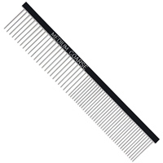
Combs
Combs come in many sizes for many purposes, however the comb of choice for most PWD grooming tasks is the Greyhound comb. The Greyhound comb is an essential tool for fluffing, detangling and removing dead hair. Also called Poodle comb.

Clippers & Blades

Clippers
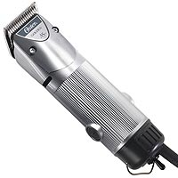
There are many models of clippers available in a variety of price ranges. Some models have snap-on blades whereas others require tools to change blades. It is important to learn how to use your clippers properly so you do not hurt your dog’s skin. Proper clipper maintenance is necessary to make sure you get a long life from whatever product you choose.

Oster clippers tend to be reliable “workhorse” type clippers, however they are a bit heavier and noisier than some of the other brands. Andis clippers run quieter and cooler than the Osters, but are usually a bit more expensive.

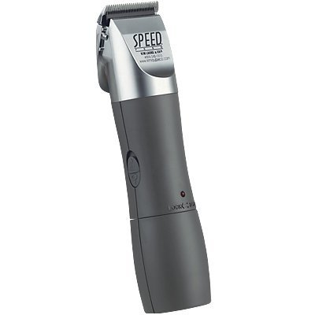
Laube makes a new “Speed Feed” clipper that is cordless and only 7" long. Clipper Kit includes: Speed Feed trimmer, Blade oil and brush, EZ snap-on blades with 5 size adjustments (sizes 40, 30, 15, 10, and 9), stand charger and two batteries, four snap-on combs. Because this trimmer can be adjusted for multiple blade sizes, you will not need to purchase as many clipper blades for use with this device.

Blades
There are many different types and sizes of blades to choose from. Every blade has different specifications, characteristics and each produces different cuts. Blades are available from grooming suppliers. Blades are actually the composite of two blades, the top blade which is the "comb." The comb feeds hair into the lower cutting blade. Only the cutting blade moves back and forth through the motor of the clipper.

Blades vary in the "cut" they provide, or the length of the hair that remains after being clipped by the blade. Cut sizes vary whether you are cutting with the grain of the coat, or against the grain of the coat (back-blading). Going with the grain of the coat leaves approximately twice as much cut length as going against the grain.

In blade sizing the higher the number associated with the blade, the shorter the blade will leave the coat. If the letter “F” follows the blade size number, it indicates that the blade is a “finishing blade”. When you have a choice, the finishing blade is usually your blade of choice.
Blade care is important. Dull blades are simply ineffective.
Following are the blades we use most frequently on PWDs. Clean the hair from the blade after use with a toothbrush and slide the blades to remove the hair from between the blades. Then oil and store in a dry place.

BODY CUTTING
Size | Cut | Description
 | 3/4” | Available through various suppliers
3-3/4 | 1/2" / 13 mm
4F | 3/8" / 9.5 mm | Full Tooth finishing blade version of the Size 4.
5F | 1/4" / 6.4 mm | Full Tooth finishing blade version of the Size 5.
7F | 1/8" / 3.2 mm | Full Tooth finishing blade version of the Size 7.
ALL PURPOSE CUTTING
Size | Cut | Description
10 | 1/16" / 1.6 mm | Underbody areas such as the stomach and genital areas. Short, popular blade.
40 | 1/100"" / .25 mm | Foot pads and as a base blade for a snap-on comb. Close cut.

Snap-on Combs

Snap-on comb attachments are a great way for an inexperienced groomer to cut the coat to a consistent length. “Snap-on combs" may also be referred to as blade guards, blade grips and blade attachments.

Snap-on comb attachments are available from grooming suppliers. Ensure that the snap-on combs you desire will fit on the clippers you use. Not all combs work on all clippers.
Comb lengths usually used for PWDs would include ½”, ¾”. 1”, 2”.

Snap-on combs are attached to the blade end of a clipper over the blade. They are best used over a #10 blade. Snap-on combs will not go through matts or curls, so the coat must be thoroughly brushed out before using them.

Generally, you will use the snap-on comb in the direction of coat growth, although with a flat-lying wavy coat we will sometimes “back blade” the hair by using the clippers against the direction of growth. Your objective is to create as even a result as possible. Once done, use scissors to smooth any uneven spots.
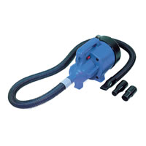
Dryers
Forced air dryers are the dryer of choice for PWDs. Forced air dryers generally use room temperature air to blow water off the dog, rather than heated air to evaporate water off the dog. The cooler temperature will prevent drying the skin. To correctly use a forced air dryer the nozzle should be held almost directly on the surface of the dog’s skin. Forced air dryers are not inexpensive, but a reasonably priced brand is the Double K ChallengAir.
Scissors & Shears

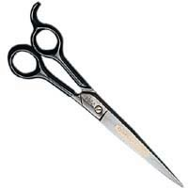
There are many types including straight shears, curved shears, blunt-tipped shears and thinning shears. For basic pet dog trimming straight shears are really the only thing you will require, although some people are reluctant to trim around the eye area with anything other than blunt-tipped shears. You should be able to get a reasonably priced pair of shears for around $80. It is nice to be able to test the shears for comfort before you buy. Look for a blade length of around 7-8 inches or so (no less).

Nail Clippers

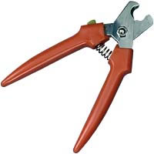
Nail clippers are essential tools for groomers and come in more than one style. We recommend heavy duty “pliers” style nail trimmers. You can also grind your dog’s nails with a grinding tool. This will allow you to get the nail shorter and smooth the edges.
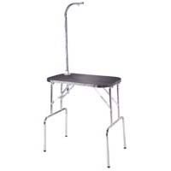
Grooming Tables

A fixed height grooming table with grooming arm, is not a required tool, but is strongly recommended. It is helpful if the table matting is a light color (i.e. gray) which will let you see the edges of your dog’s feet better than a darker (black) surface. The dog will get better traction on the table if the ridges in the mat run perpendicular to the grooming arm clamp.

De-Matting Tools

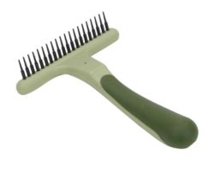
Brushes and combs may not be enough to break-up significant matting. De-matting tools do the job. Undercoat rakes break the matt up into smaller pieces which are then more easily removed with brush and comb action. This is a much more humane solution for your dog than taking him to the groomer matter or ripping the mats out with a regular comb. Use on damp or wet coats.

De-Matting

Owners must address their responsibilities to care for their dog's haircoat with regular brushing and combing. Brushing removes dead hair shed from the coat. Hair shed allowed to remain in medium to long coated pets can easily tangle and matt and cause a pet discomfort and in severe cases, affect their health.

Removing matts means slow down, don't rush. It takes patience and compassion for the pet. Detangling tools are available to make the procedure as efficient as possible in the shortest possible time without rushing. Conditioner left in the coat after and bath helps the comb or rake glide through the coat more easily with less breaking of coat hairs.

You should have a slicker brush, steel comb, a matt splitter and sometimes scissors. One of the most important aspects of dematting is handling the pet. You reduce tugging and pulling by taking the matt between your fingers and breaking it up. The more you break a large matt down into several smaller pieces the better, and then work to remove each smaller separated piece of the larger matt. A brush makes this chore fairly easy. This makes it much easier to hold the matts between your fingers and not carry the tugging and pulling motion to the pet. What a difference for the pet!

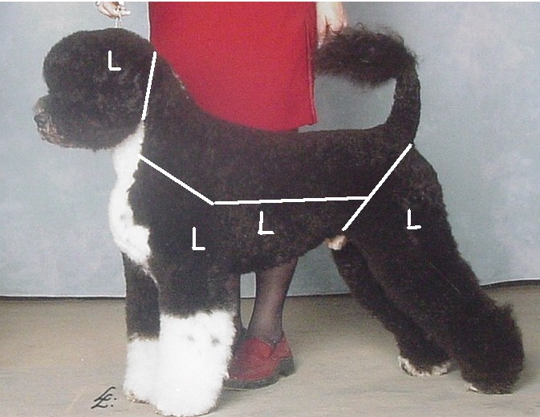
Very dense and large matts are usually best split.
You will know when you have fully combed out and removed all matts when you can use the steel comb to fully comb the pet without obstructions. Remember we recommend limiting each session of detangling to no more than 30 minutes.

Most pet owners do not want the length of a show dog (which is scissored rather long) so I use a 1 or 1 1/2 snap on over the body, starting about two inches behind the occiput. Leave the entire head full from a line at the back of the jaw and meeting your neck line at the back. The body is then scissored over. PWDs technically come in two coats, the wavy and the curly, but you also find some described as "loose curly" which fall somewhere in between. Keep in mind the curlier the coat the shorter the snap on will cut. When in doubt start with the #1. The legs are scissored full with full feet. Front legs should be straight columns, rear very tight at the anal area and down the back of the leg to about 2" above the hock, then longer from the hock down to build some angulation. The front and sides of the legs are longer, blended smoothly all around. Also clip the top 2/3 of the tail with the same snap on, leaving the end untouched in a "flag". Tail is then scissored so it is slightly wider at the base than at the start of the flag.

The topline is supposed to be level, so scissor after your clipper work to make any adjustments needed such as correcting a steep croup or roached back. Many PWDs are also very close behind and need to have the inside of the hock scissored shorter than the outside to give some space between the legs.

The head is the most unique and difficult part of the breed. Be careful on wavy coats as they tend to cowlick and too big a snip at one time can send the hair the wrong direction. The topknot is shorter that a poodle, fuller in front for a slight recess to the eyes, but many pet owners want to see more eye. The top is blended into the ear coat, there is no break. The ears themselves are scissored heart shaped, very close to the leather at the tip and 1 inches at the sides. Once the outline is set, the inside of the ear is scissored to blend smoothly and the outside is scissored to blend with the sides and into the topknot. No more than 1 inch of coat is left on the outsides of the ear. The back of the topknot is blended smoothly into the neck (no break) using that two inches you left in your patterning. The breed is supposed to be short necked, the extra thickness on the back of the neck helps give that impression.

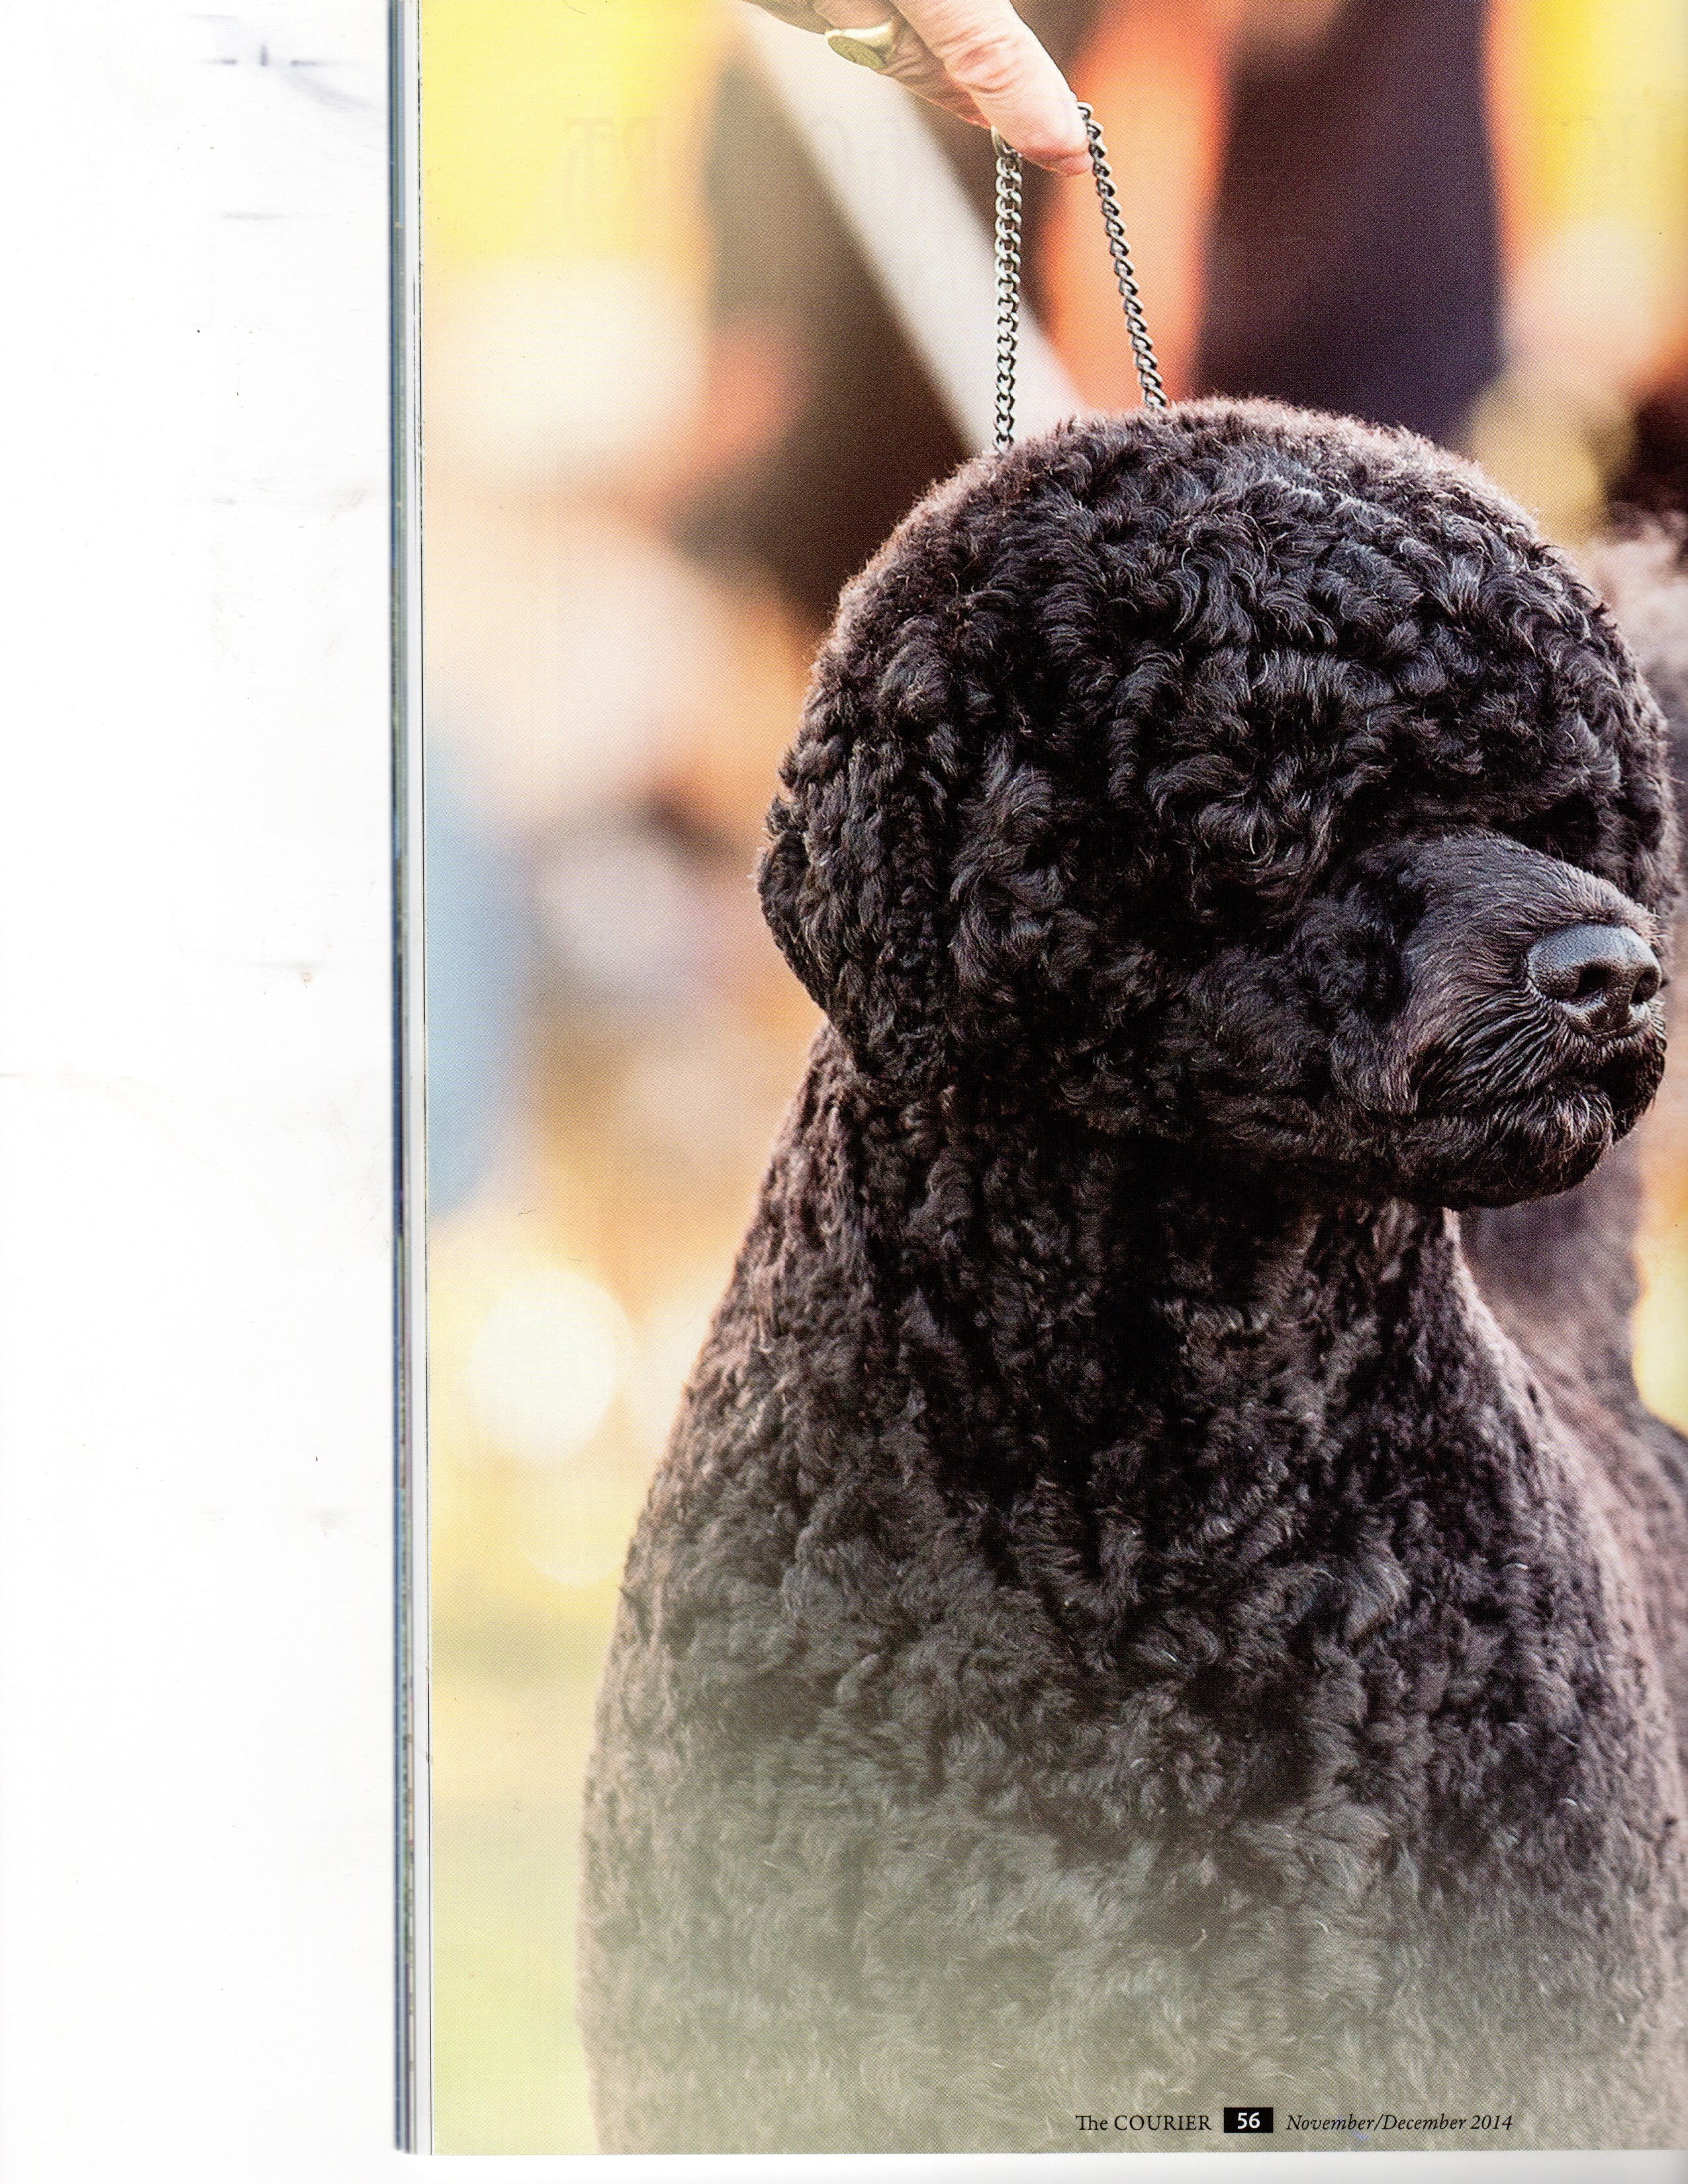
The muzzle is scissored differently depending on the type of coat. Start with the lower jaw and scissor a straight line which starts about 3/4 of an inch below the front of the lower lip and continues to the back of the mouth ending about 1/4 inch below the jaw. (In other words, there is more hair at the front of the lower jaw than at the back, but the line is straight, not curved.)

Once the lower lip line in, scissor the bottom edge of the muzzle hair to match.
Don't curve from the front of the lips, just scissor a straight line back.On a wavy, looking at the muzzle from the side, comb the front of the muzzle hair forward and remove any coat which extends beyond a straight line from the tip of the nose square with the bottom of the muzzle you just trimmed.

The muzzle is mostly done except that on some dogs you may want to thin out a bit under the eyes so that when viewed from above the muzzle is square, not wedge shaped. On a curly, use the comb to pick up the hair all around the muzzle and scissor around the top and sides of the muzzle to create a cylinder. Scissor the hair out from the bridge of the nose. Pull the hair at the front of the muzzle forward and scissor straight to form the bottom of the cylinder. Blend from about mid muzzle to the wider hair at the side of the head.

Next shorten the upper neck where it meets the jaw. You can scissor or use a 4 blade to get the length here, cut out about a two inch triangle at the top of the neck and then blend into the rest of the neck hair left long from the breast bone down. The sides of the face are next. Pull back one ear and look at the dog head on and scissor the cheeks so that they blend in with the topknot creating a round head. Think round. Watch out on wavy coats that you don't get too short here, it will flatten.. Pull the ear forward toward the muzzle and scissor the hair behind the ear to continue your "ball" into the back of the topknot.



